Exercise

**1.How are inline and block elements different from each other?**

Block level elements and inline elements are different from each other:

i) Block elements are always start on a new line whereas an inline elements does not start on a new line.

ii) Block elements always takes up the full width available whereas an inline elements only takes up as much width as necessary.

iii) Block elements has a top and a bottom margin whereas an inline elements does not.

iv) Examples for Block elements are **<div>, <form>,<ul>,etc.** and examples for inline elements are **<span>, <img>,<a>,etc.**

**2.Explain the difference between visibility:hidden and display:none**

The visibility is the property that specifies the visibility behaviour of an element . It is used to specify whether an element is visible or not in a web document. The element having **visibility:hidden** makes the text invisible in a web document and takes up the space in the web document.

For example: <div>

There is a word <span style=”visibility:hidden”>hidden</span> in the text.

</div>

**Output:** There is a word in the text.

The **display:none** property is used to specify whether an element is exist or not on the website.

For Example: <div>

There is a <span style=”display:none”>word</span>having property display:none.

</div>

**Output:** There is a having property display:none.

**3. Explain the clear and float properties.**

The **clear** property is used to specify which side of floating elements are not allowed to float.

The values a clear property can have are: none, left, right, both and inherit.

**none:** It allows the element can be float on both sides.

**left:** It does not allow an element to float on the left side of an element which has this property clear:left.

**right:** It does not allow an element to float on the right side of an element which has this property clear:right.

**both:** It does not allow elements to float on both the sides.

**Initial:** It sets the property to its default value.

For example: <html>

<head>

<style>

.first{

background-color: yellow;

width: 100px;

height: 100px;

float: left;

}

.second{

background-color: lightblue;

width: 100px;

height: 100px;

clear: left;

}

</style>

</head>

<body>

<div class="first">

This is the first div element.

</div>

<div class="second">

This is the second div element.

</div>

</body>

</html>

**Output:** 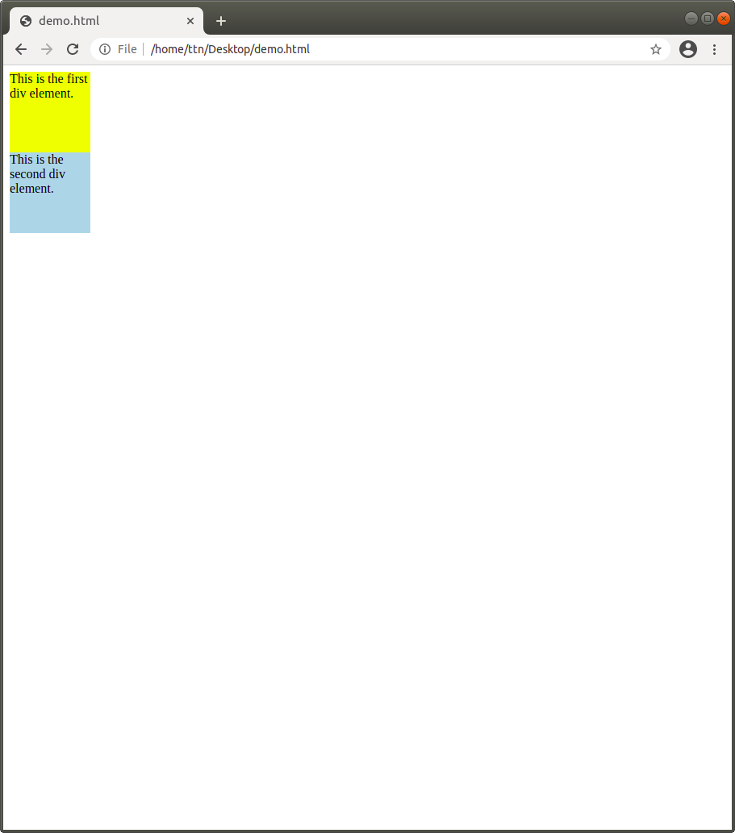

Second div has a property clear:left. So, it does not allow an element to float on the left side of it.

The **float** property is used for positioning the content. It forces any element to float (right, left, none, inherit) inside its parent body with rest of the element to wrap around it. It is applied to float an element horizontally only.

For example: 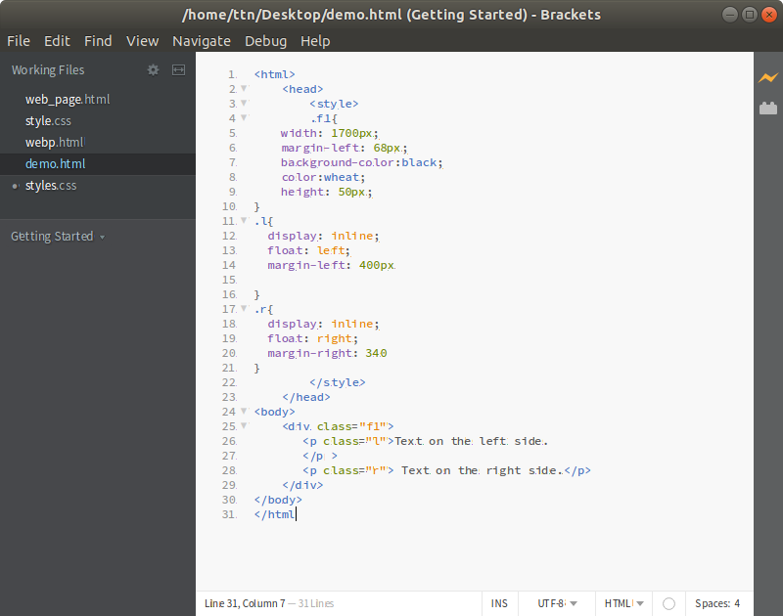

**Output:**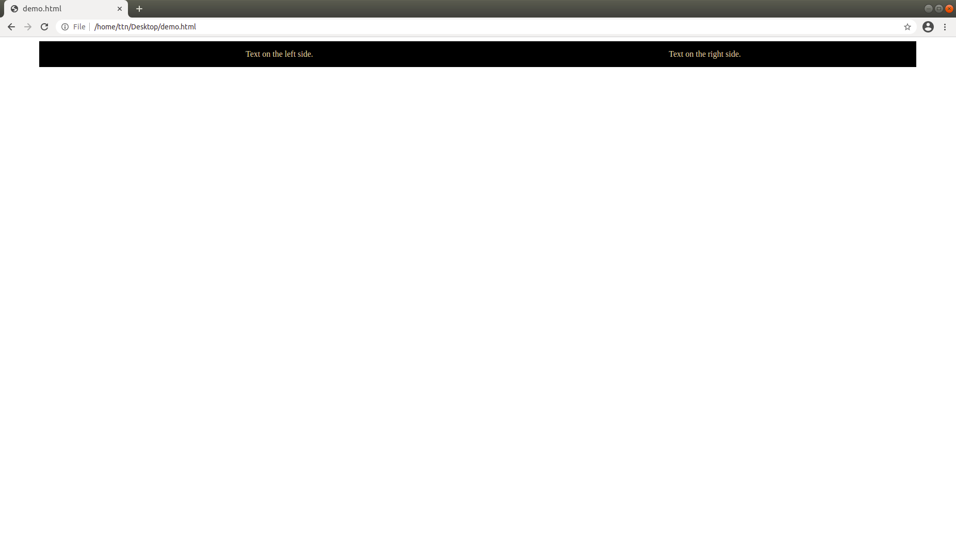

**4. explain difference between absolute, relative,fixed and static.**

absolute, relative, fixed and static are position property and used for positioning of elements.

**absolute:** An element with position: absolute is positioned relative to the nearest positioned parent element. If an absolute positioned element has no positioned parent, it uses the document body, and moves along with page scrolling.

**relative:** An element having position: relative is positioned relative to its normal position. We can move the element from its current position. So, by setting left, right , top and bottom properties of relatively positioned elements, we can adjust the position of an element according to the property given.

**fixed:** An element having fixed position is positioned relative to the viewport, or the browser window itself. When the page is scrolled, fixed position element will stay right there where it is. This property is mainly used when we want our element to remain visible even when the page is scrolled.

**static:** It is default for every single page element. An element having **position:static** property means that the element will flow into page as it normally would. And if there is some positioning applied to an element it forcefully remove that applied value.

**5. Write the HTML code to create a table in which there are 4 columns( ID , Employee Name, Designation, Department) and at least 6 rows. Also do some styling to it.**

<html>

<head>

<style>

table,th,td{

border: 2px solid black;

border-collapse: collapse;

text-align: center;

padding: 5px;

}

table{

width:100%;

}

th{

background-color: aquamarine;

}

tr{

background-color: azure;

}

h2{

text-align: center;

}

</style>

</head>

<body>

<h2>Employee Database</h2>

<table>

<tr>

<th>ID</th>

<th>Employee Name</th>

<th>Designation</th>

<th>Department</th>

</tr>

<tr>

<td>E101</td>

<td>John</td>

<td>Software Engineering</td>

<td>Development</td>

</tr>

<tr>

<td>E102</td>

<td>Smith</td>

<td>Software Testing</td>

<td>Testing</td>

</tr>

<tr>

<td>E103</td>

<td>Stark</td>

<td>Front-end developer</td>

<td>FEEN</td>

</tr>

<tr>

<td>E104</td>

<td>Evans</td>

<td>Software Engineering</td>

<td>Development</td>

</tr>

<tr>

<td>E105</td>

<td>David</td>

<td>Front-end developer</td>

<td>FEEN</td>

</tr>

<tr>

<td>E106</td>

<td>Tony</td>

<td>Software Testing</td>

<td>Testing</td>

</tr>

</table>

</body>

</html>

**Output:** 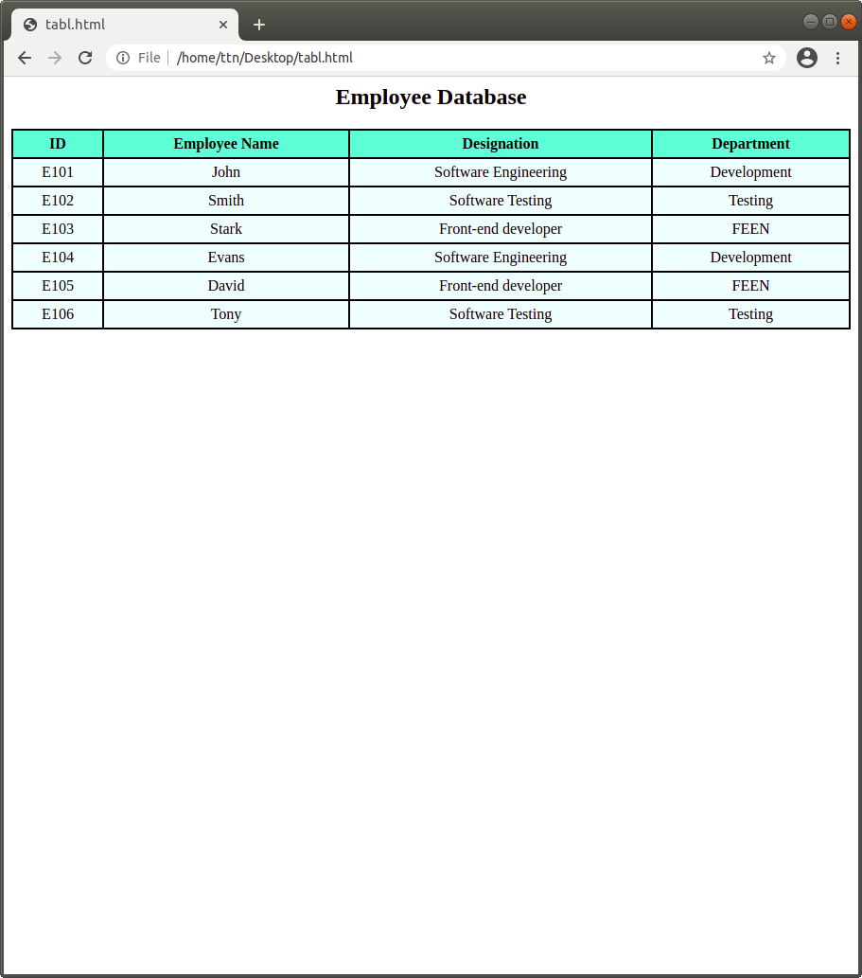

**6. Why do we use meta tags?**

Meta tags defines metadata about an HTML document. It is used to specify character set, page description, keywords and viewport settings.

For Example: i) <meta name=”keywords” content=”HTML,CSS”> : It defines keywords for search engines.

i) <meta name=”viewport” content=”width=device-width,initial-scale=1.0”> : It is used for setting the viewport to make our website look good in all devices. It gives the browser instructions on how to control the page’s dimensions and scaling.

**7. Explain box model.**

An HTML elements can be considered as boxes. So, a box model is essentially a box that wraps around every HTML element and it consists of margins, borders, padding and the content inside the element.

**margin:** It clears the area outside the border of an element.

**padding:** It clears the area around the content.

**content:** Content is the text or any image appears.

Example: <html>

<head>

<style>

.check{

margin: 50px;

padding: 20px;

border: 2px solid black;

text-align: center;

}

</style>

</head>

<body>

<div class="check">

This is the random text used for styling.

</div>

</body>

</html>

**Output:** 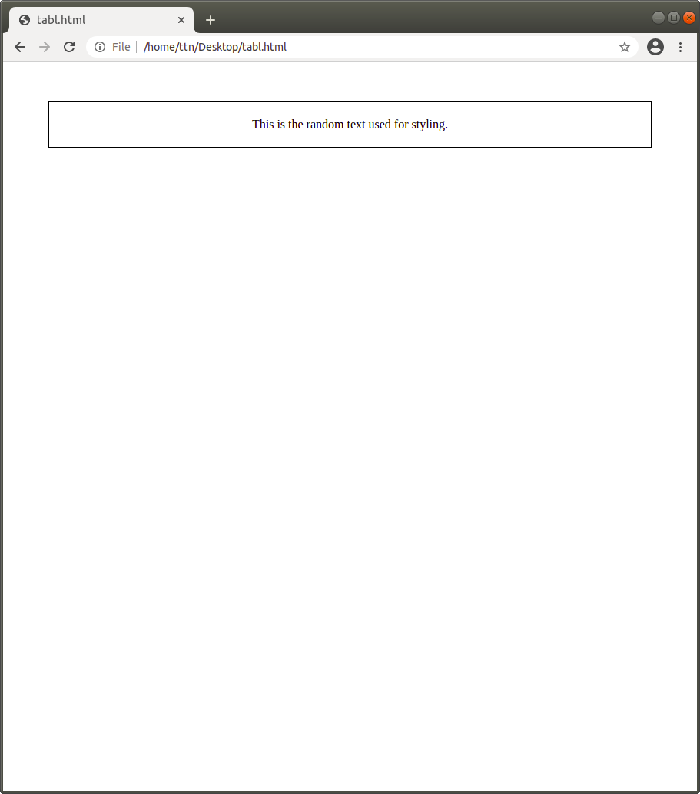

**8. What are the different types of CSS Selectors?**

CSS Selectors are used to find the HTML elements we want to style. CSS selectors select HTML elements according to its id, class, attribute etc.

CSS selectors are categorized into 5 categories:

**Simple Selectors** : It selects elements based on their name, id and class.

**Combinator Selectors** : It selects elements based on a specific relationship between them. Between the simple selectors, we can include a combinator.

E.g., div p { background-color:yellow;

}

**Pseudo-class Selectors** : It selects elements based on a certain state. It can be used to style an element when a mouse hovers over a link, when links are visited.

**Pseudo-elements Selectors** : It selects and style a part of an element. It an be used to style the first letter, or line af an element.

**Attribute Selectors** : It selects elements based on an attribute or attribute value.

E.g., <style>

a[target=”_blank”]{ background-color:yellow;

}

</style>

<a href=”[www.xyz.com](http://www.google.com)” >xyz Site</a>

<a href=”[www.google.com](http://www.google.com)” target=”_blank”>Google Site</a>

The link with target=”_blank” gets yellow background.

**9. Define Doctype.**

Doctype is the first line of code required in every HTML document. It is an instruction to the web browser about what version of HTML the page is written. It is not an element or a tag.

Example: <!DOCTYPE html>

**10. Explain 5 HTML5 semantic tags.**

**i) section tag :** It defines a section in a document. It can be used to divide the page into sections of introduction, any content and contact information.

**ii) article tag :** It specifies independent, self-contained content. It contains blog post, newspaper article etc.

**iii) header tag :** It represents a introductory content or a navigation bar. It contains logo or icon , headings.

**iv) footer tag :** It defines a footer for a document. It contains copyright information, contact information, sitemap, etc.

**v) nav tag :** It defines a set of navigation links.

E.g., <nav>

<a href=”#”>link1</a>

<a href=”#”>link2</a>

<a href=”#”>link3</a>

</nav>

**11. Create HTML for web-page.jpg (check resources, highest weightage for answers)**

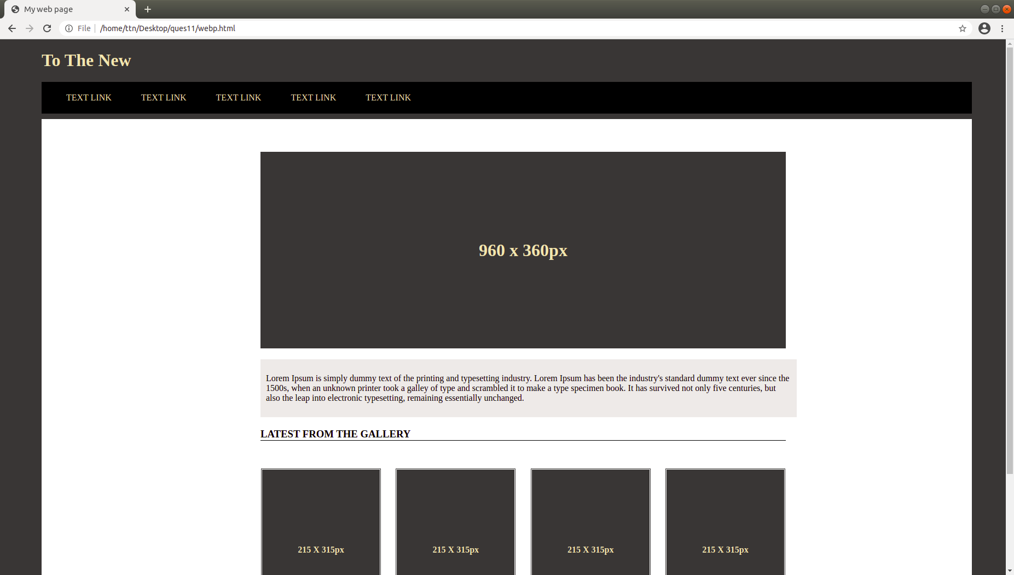 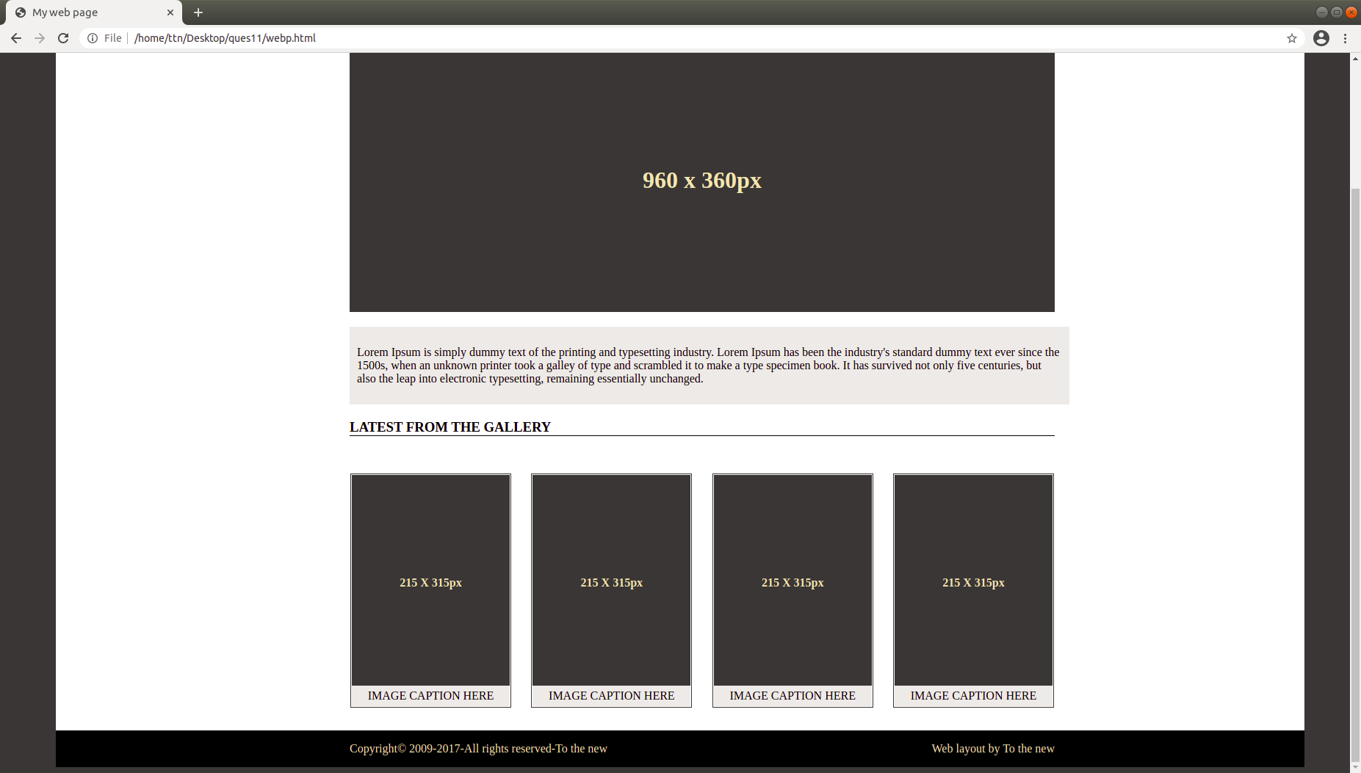

**12. Create HTML for form.png (check resources, highest weightage for answers)**

